OOSD TU259 CA3

School Management System - Design Document

1. Project Overview

Describe the problem you have selected.

This project involves developing an application that will manage the services of a school.

I will firstly focus on the students. They are divided into three categories based on the subjects available at the school, namely English, History and Math. The application needs to be able to load general information about the students from an external file, then supplement this information via three separate external files that hold information about the subjects students take. The user should be able to create, read, update and delete (CRUD) data related to the student body as a whole, individual students, subjects taken by students and grades obtained in each subject.

I will also include CRUD functionality for data about staff at the school, dividing staff members into the following categories – teacher, principal, administration, counselor and medic. This is done to broaden the scope of the school system and introduce inheritance into the design, as outlined later in this document.

Once the user has finished using the application, there will be an option to quit and save any changes made and update the related files.

What will your system be able to do?

The brief specifically states that the services provided by the management system must at least include the following - storing student information, reading and writing student information from files, computing final grades and printing a summary report to an output file.

There must also be the possibility of calculating grades for each subject based on a 100-point scale.
We are told that each module is broken down in the following way:

●​ English: Attendance 10%, Final exam 60%, Quiz 1 15%, Quiz 2 15%.
●​ History: Attendance 10%, Project 30%, Exam 1 30%, Exam 2 30%
●​ Math: Quiz average 15% (there are 5 quizzes worth 15% each that need to be
averaged), Test 1 15%, Test 2 15%, Final Exam: 55%.

What are going to be the key functionalities?

In the brief, it is stated that the system must use the following classes - Student, MathStudent, HistoryStudent, EnglishStudent, School. It is also stated that the School class should use aggregation or composition to contain relevant information about students and that MathStudent, HistoryStudent, and EnglishStudent should inherit from Student.

Although there is a requirement that MathStudent, EnglishStudent, and HistoryStudent inherit from Student, my implementation uses a more modular architecture where subject-specific logic is handled by classes in a separate Gradebook file. To satisfy the requirement for inheritance, I have applied it in the Employee class hierarchy where the sub-classes (Teacher, Principal, Administration, Counselor and Medic) inherit from the Employee class.

I use composition to create the School class based on the Student class. The Student class will store the current overall grade for each subject taken by a given student. Each subject class holds information about that subject for the student, including the grades for each continuous assessment and the current overall grade. These classes will also allow for the grade to be updated through entering in new/updated continuous assessment data. The Student class will include a method to update the overall grade for each subject for a given student.

Each of the subject classes will be stored in a file called Gradebook.py. In main, I will import these classes from Gradebook.py, which will their functionality to be accessed directly. Separate classes will be designed in a CSV-loader file that will deal with importing data and saving it.

Beyond these choices, the brief states that each class should have an __init__ and __str__ method and that for each __str__ method relevant information should be provided when their instances are printed. The system should also allow for persistent memory by ensure that when the user starts the system, it should read the files school.txt, mathstudent.txt, historystudent.txt, englishstudent.txt in the same folder as the python code and create all the necessary instances.

The system must also provide a command line interface for a school manager to log in to the system and add/remove students. There must also be provision to create, read, update and delete (CRUD) student data and print well-formatted student reports for each academic term. Finally, the system musth update the external files after any information is modified.

Which data structures are you planning to use?

The School class will contain a dictionary ({}) that will be used to store students based on unique IDs. The Student class will provide for a list ([]) where the subjects the student is studying will be stored and a dictionary to hold the overall grade for each subject (key:subject_name, value:subject_grade). Given the large number of quizzes for Maths, the results will be stored in a list that will be used by the grade calculator.

2. Text Files Format

I will be using CSV files to store the information that will be loaded when the application is launched. I have made this decision as it is easier to store information in these files due to the column-based layout and easier to read the information from these files as each piece of information is separated in a logical manner (commas, spaces, etc.).

The Student class contains many pieces of information about each student, including their full address, names and contact details of parents/guardians and the current grade for each subject taken. In the CSV files, it will be important to distinguish between strings, lists and dictionaries by ensuring that the values for each attribute (even when there are multiple values) are stored in the same cell. This information will be stored by attribute (column) for each individual student (row), with a specific csv-loader function designed to read and import the data.

For the files related to each school subject, they will also be CSV ones. Each file will contain the student ID to link back to the main CSV file, the name of the student for printing reports, the grades of each individual continuous assessment and the overall current grade based on the formulae given for their calculation.

3. Class Diagram (Optional)

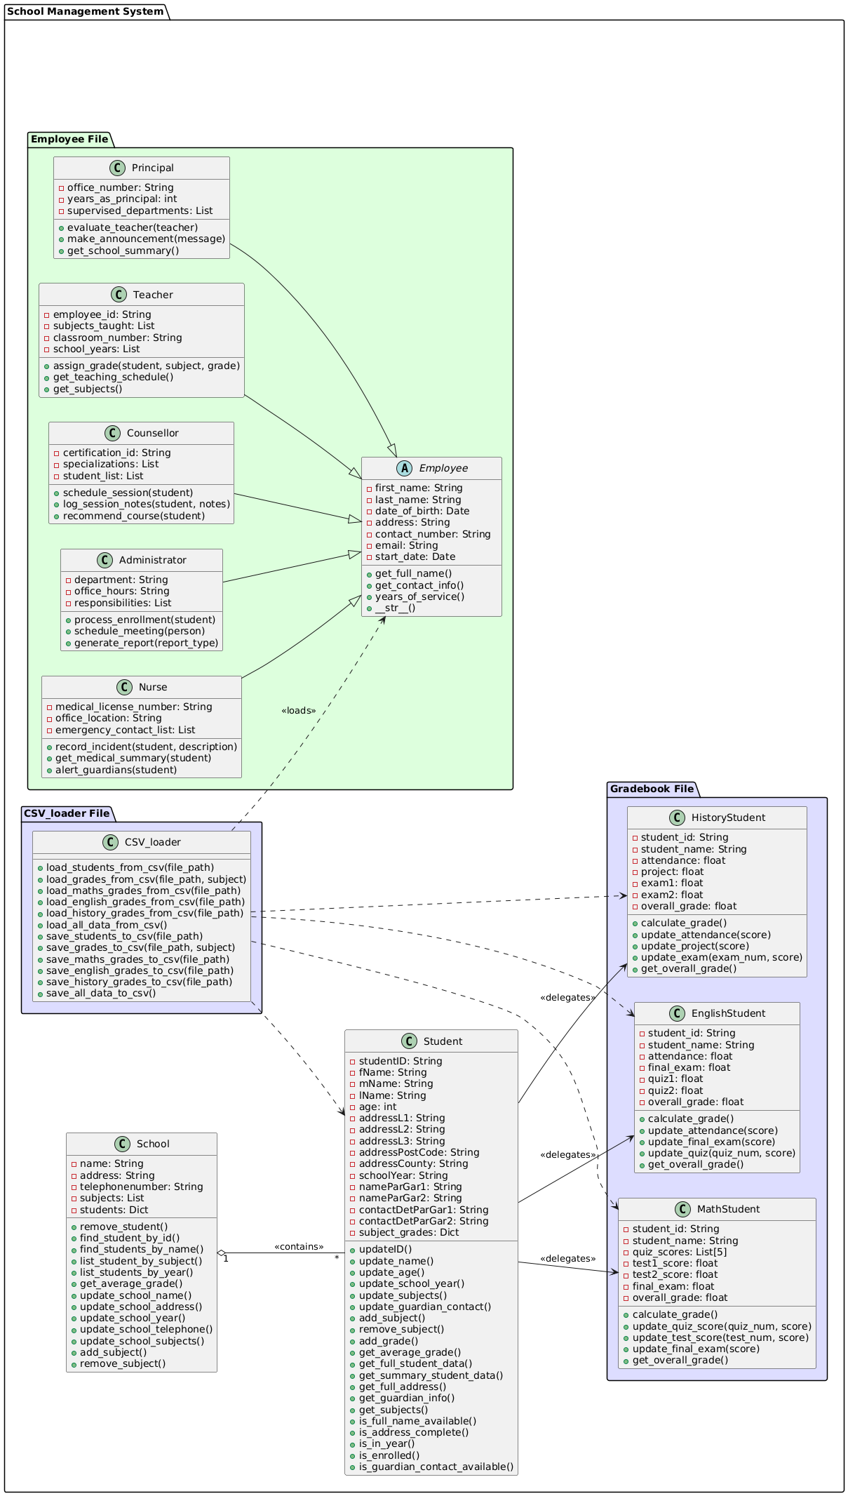
4. Class Definitions

Class | Attributes | Methods
Student | Attributes  - studentID: String  - fName: String  - mName: String  - lName: String  - age: int  - addressL1: String  - addressL2: String  - addressL3: String  - addressPostCode: String  - addressCounty: String  - schoolYear: String  - nameParGar1: String  - nameParGar2: String  - contactDetParGar1: String  - contactDetParGar2: String  - subject_grades: Dict | + updateID()  + update_name()  + update_age()  + update_school_year()  + update_subjects()  + update_guardian_contact()  + add_subject()  + remove_subject()  + add_grade()  + get_average_grade()  + get_full_student_data()  + get_summary_student_data()  + get_full_address()  + get_guardian_info()  + get_subjects()  + is_full_name_available()  + is_address_complete()  + is_in_year()  + is_enrolled()  + is_guardian_contact_available()
School | - name: String  - address: String  - telephonenumber: String  - subjects: List  - students: Dict | + remove_student()  + find_student_by_id()  + find_students_by_name()  + list_student_by_subject()  + list_students_by_year()  + get_average_grade()  + update_school_name()  + update_school_address()  + update_school_year()  + update_school_telephone() + update_school_subjects()  + add_subject()  + remove_subject()
Class | Attributes | Methods
Employee | - first_name: String  - last_name: String  - date_of_birth: Date  - address: String  - contact_number: String  - email: String  - start_date: Date | + get_full_name()  + get_contact_info()  + years_of_service()  + __str__()
Teacher | - employee_id: String  - subjects_taught: List  - classroom_number: String  - school_years: List | + assign_grade(student, subject, grade)  + get_teaching_schedule() + get_subjects()
Principal | - office_number: String  - years_as_principal: int  - supervised_departments: List | + evaluate_teacher(teacher)  + make_announcement(message)  + get_school_summary()
Nurse | - medical_license_number: String  - office_location: String  - emergency_contact_list: List | + record_incident(student, description)  + get_medical_summary(student)  + alert_guardians(student) }
Administrator | - department: String  - office_hours: String  - responsibilities: List | + process_enrollment(student)  + schedule_meeting(person)  + generate_report(report_type)
Counsellor | - certification_id: String  - specializations: List  - student_list: List | + schedule_session(student)  + log_session_notes(student, notes)  + recommend_course(student)

Class | Methods
CSV_Loader | + load_students_from_csv(file_path)  + load_grades_from_csv(file_path, subject)  + load_maths_grades_from_csv(file_path)  + load_english_grades_from_csv(file_path)  + load_history_grades_from_csv(file_path)  + load_all_data_from_csv()  + save_students_to_csv(file_path)  + save_grades_to_csv(file_path, subject)  + save_maths_grades_to_csv(file_path)  + save_english_grades_to_csv(file_path)  + save_history_grades_to_csv(file_path) + save_all_data_to_csv() }

Class | Attributes | Methods
MathStudent | - student_id: String  - student_name: String  - quiz_scores: List[5]  - test1_score: float  - test2_score: float  - final_exam: float  - overall_grade: float | + calculate_grade()  + update_quiz_score  (quiz_num, score)  + update_test_score  (test_num, score)  + update_final_exam(score)  + get_overall_grade()
EnglishStudent | - student_id: String  - student_name: String  - attendance: float  - final_exam: float  - quiz1: float  - quiz2: float  - overall_grade: float | + calculate_grade()  + update_attendance(score)  + update_final_exam(score)  + update_quiz  (quiz_num, score)  + get_overall_grade()
HistoryStudent | - student_id: String  - student_name: String  - attendance: float  - project: float  - exam1: float  - exam2: float  - overall_grade: float | + calculate_grade()  + update_attendance(score)  + update_project(score)  + update_exam  (exam_num, score)  + get_overall_grade() }

5. Planned Functionalities

The user will be able to:
1) Load student data from a CSV file,
2) Create, read, update and delete information about the school
3) Create, read, update and delete data on individual students
4) Create, read, update and delete data on the subjects taken by individual students
5) Create, read, update and delete information on members of staff at the school
6) Save any modifications before elegantly quit the application

6. Additional features

I intend to add the following features that are not specifically required:

1) A graphical interface for the user to allow some of the operations outlined above to be performed by clicking on buttons and directly inputting modifications rather than solely working at command-line level, which can be off-putting for many ordinary users.

2) There will be the possibility of generating basic graphs based on the student and subject data.

3) I will use operation overloading to define a greater than operator (>) which will allow me to sort students by grade in each subject-specific

4) I may use descriptors to gain extra information about the operations of the application, such as the order in which the operations occur or the run-times for the various components.

5) As I did not specifically include inheritance as required by the project brief, I have added the employee class with various subclasses to achieve this. Such an addition also enables greater information storage for students (information about their teachers) and subjects (who teaches what).

7. Expected Challenges and Solutions

Appendix 1

PlantUML code for the class diagram:

@startuml
' Set diagram to horizontal orientation
left to right direction

' Option 1: Make the system component wider
skinparam componentStyle rectangle
skinparam minClassWidth 200
' Using left to right direction helps with centering
left to right direction
left to right direction

package "School Management System" {

' Gradebook Module
package "Gradebook File" #DDDDFF {

class MathStudent {
- student_id: String
- student_name: String
- quiz_scores: List[5]
- test1_score: float
- test2_score: float
- final_exam: float
- overall_grade: float
+ calculate_grade()
+ update_quiz_score(quiz_num, score)
+ update_test_score(test_num, score)
+ update_final_exam(score)
+ get_overall_grade()
}

class EnglishStudent {
- student_id: String
- student_name: String
- attendance: float
- final_exam: float
- quiz1: float
- quiz2: float
- overall_grade: float
+ calculate_grade()
+ update_attendance(score)
+ update_final_exam(score)
+ update_quiz(quiz_num, score)
+ get_overall_grade()
}

class HistoryStudent {
- student_id: String
- student_name: String
- attendance: float
- project: float
- exam1: float
- exam2: float
- overall_grade: float
+ calculate_grade()
+ update_attendance(score)
+ update_project(score)
+ update_exam(exam_num, score)
+ get_overall_grade()
}
}

' Horizontal spacer
class " " as spacerH1 #FFFFFF {}
hide spacerH1

' CSV_loader Module moved to middle
package "CSV_loader File" #DDDDFF {

class CSV_loader {
+ load_students_from_csv(file_path)
+ load_grades_from_csv(file_path, subject)
+ load_maths_grades_from_csv(file_path)
+ load_english_grades_from_csv(file_path)
+ load_history_grades_from_csv(file_path)
+ load_all_data_from_csv()
+ save_students_to_csv(file_path)
+ save_grades_to_csv(file_path, subject)
+ save_maths_grades_to_csv(file_path)
+ save_english_grades_to_csv(file_path)
+ save_history_grades_to_csv(file_path)
+ save_all_data_to_csv()
}
}

' Core classes
together {
class Student {
- studentID: String
- fName: String
- mName: String
- lName: String
- age: int
- addressL1: String
- addressL2: String
- addressL3: String
- addressPostCode: String
- addressCounty: String
- schoolYear: String
- nameParGar1: String
- nameParGar2: String
- contactDetParGar1: String
- contactDetParGar2: String
- subject_grades: Dict
+ updateID()
+ update_name()
+ update_age()
+ update_school_year()
+ update_subjects()
+ update_guardian_contact()
+ add_subject()
+ remove_subject()
+ add_grade()
+ get_average_grade()
+ get_full_student_data()
+ get_summary_student_data()
+ get_full_address()
+ get_guardian_info()
+ get_subjects()
+ is_full_name_available()
+ is_address_complete()
+ is_in_year()
+ is_enrolled()
+ is_guardian_contact_available()
}

class School {
- name: String
- address: String
- telephonenumber: String
- subjects: List
- students: Dict
+ remove_student()
+ find_student_by_id()
+ find_students_by_name()
+ list_student_by_subject()
+ list_students_by_year()
+ get_average_grade()
+ update_school_name()
+ update_school_address()
+ update_school_year()
+ update_school_telephone()
+ update_school_subjects()
+ add_subject()
+ remove_subject()
}
}

' Horizontal spacer
class " " as spacerH2 #FFFFFF {}
hide spacerH2

' Employee Module
package "Employee File" #DDFFDD {
abstract class Employee {
- first_name: String
- last_name: String
- date_of_birth: Date
- address: String
- contact_number: String
- email: String
- start_date: Date
+ get_full_name()
+ get_contact_info()
+ years_of_service()
+ __str__()
}

class Teacher {
- employee_id: String
- subjects_taught: List
- classroom_number: String
- school_years: List
+ assign_grade(student, subject, grade)
+ get_teaching_schedule()
+ get_subjects()
}

class Principal {
- office_number: String
- years_as_principal: int
- supervised_departments: List
+ evaluate_teacher(teacher)
+ make_announcement(message)
+ get_school_summary()
}

class Nurse {
- medical_license_number: String
- office_location: String
- emergency_contact_list: List
+ record_incident(student, description)
+ get_medical_summary(student)
+ alert_guardians(student)
}

class Administrator {
- department: String
- office_hours: String
- responsibilities: List
+ process_enrollment(student)
+ schedule_meeting(person)
+ generate_report(report_type)
}

class Counsellor {
- certification_id: String
- specializations: List
- student_list: List
+ schedule_session(student)
+ log_session_notes(student, notes)
+ recommend_course(student)
}
}

' Actual relationships
School "1" o-- "*" Student : \n<<contains>>

Teacher --|> Employee
Principal --|> Employee
Nurse --|> Employee
Administrator --|> Employee
Counsellor --|> Employee

Student --> MathStudent : <<delegates>>
Student --> EnglishStudent : <<delegates>>
Student --> HistoryStudent : <<delegates>>

' Unlabeled links from CSV_loader
CSV_loader ..> Student
CSV_loader ..> MathStudent
CSV_loader ..> EnglishStudent
CSV_loader ..> HistoryStudent
CSV_loader ..> Employee : <<loads>>
}
@enduml

